**Matlab HW3 Report**

**電機二 B09602017 白宗民**

**Part I:**

1. **Figure** x[n] vs. n:

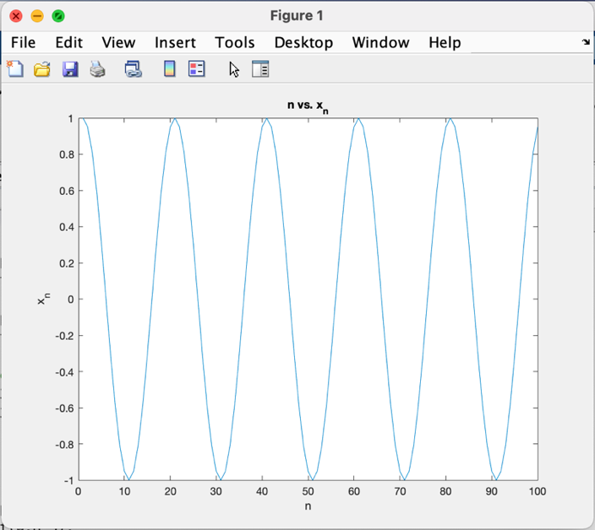

**(b) Figure** magnitude response vs. w **/** phase response vs. w **/** y[n] vs. n:

L = 3, fc = 0.05

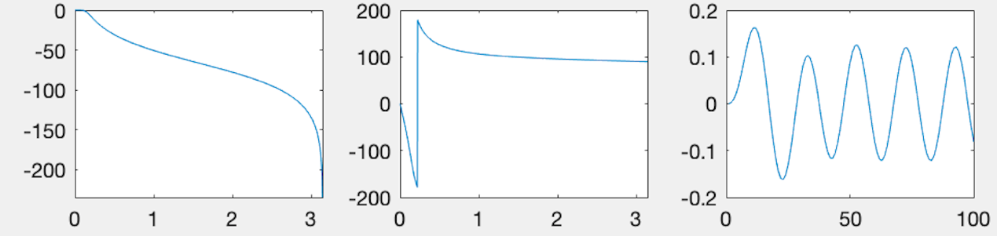

**H(ejw) =**

**(c) Figure** magnitude response vs. w **/** phase response vs. w **/** y[n] vs. n:

L = 7, fc = 0.05

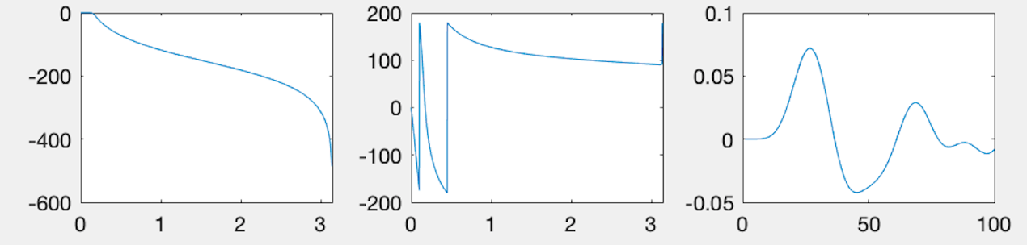

**H(ejw) =**

1. **Figure** magnitude response vs. w **/** phase response vs. w **/** y[n] vs. n:

L = 3, fc = 0.5

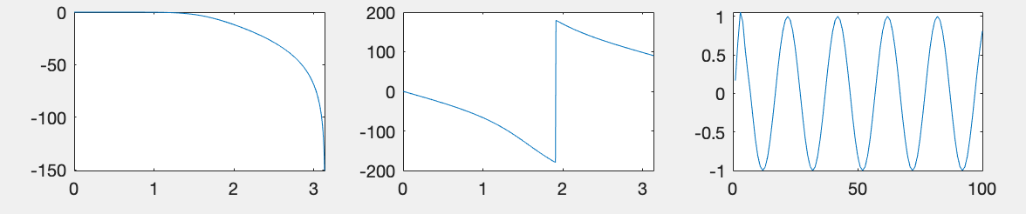

**H(ejw) =**

**(e) What’s the effect of increasing L? fc?**

For L:

1. As we can see, if L is increased, the coefficient of the numerator will be extremely small (ex: $e^{-6}$*).
2. Graphs of the magnitude and phase are similar while the output is different in shape.

For fc:

1. If fc is increased, the coefficient of the numerator will be larger.
2. Graphs of the magnitude and phase are different while the output is similar in shape.

**Part II:**

We know that

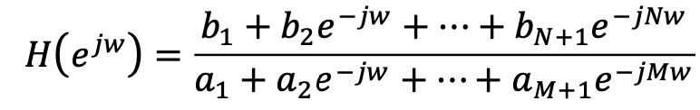

, I’ll give N, M, and the coefficients of the transfer functions below.

1. **Figure x[n] vs. n:**

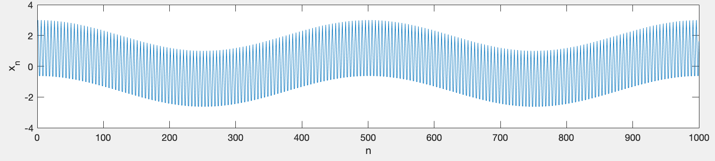

1. **y[n] vs. n (lowpass):**

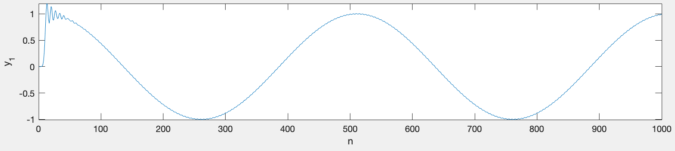

**M = N = 16**

**Cutoff frequency = 0.3**

**b = [ 0 0 0 0.0001 0.0002 0.0006 0.0010 0.0015**

**0.0017 0.0015** **0.0010 0.0006 0.0002 0.0001 0 0 0 ]**

**a = [ 1 -6.3922 20.6669 -43.9603 68.1356 -81.0183 76.0628**

**-57.2897 34.8775 -17.1764 6.8058 -2.1431 0.5249 -0.0966 0.0126 -0.001 0 ]**

1. **y[n] vs. n (bandpass):**

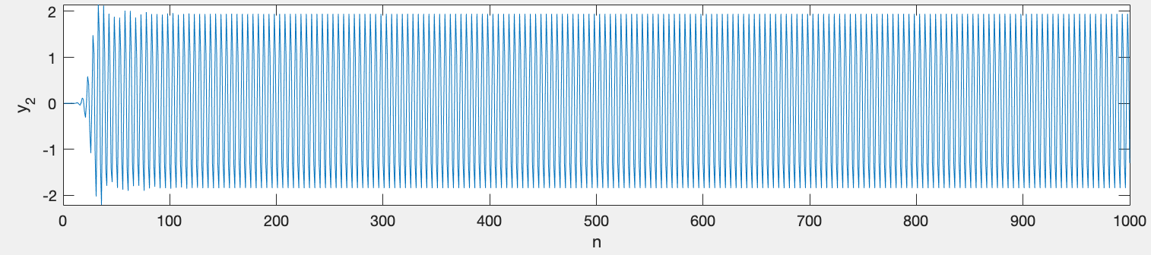

**M = N = 32**

**Bandpass frequency = [ 0.25 0.5 ]**

**b =[ 0.0001 0 -0.0009 0 0.0030 0 -0.0060 0**

**0.0076 0 -0.0060 0 0.0030 0 -0.0009 0 0.0001]**

**a = [ 1.0000 -4.9638 14.8654 -31.5441 52.7796 -71.9998 82.5840 -80.4046 67.1741 -48.0827 29.5033 -15.3304 6.6791 -2.3614 0.6565 -0.1286 0.0155 ]**